NORD VUE EQ CENTRE, RIDDEN SHOWING SHOW,

Sat 8th Mar, Sun 6th Apr, Sat 26th Apr, Sun 11th May, Sat 31st May, RIDDEN SPARKLE Sun June 15th

*This Event is being organised by Ellen Jones as an SPARKET EQUESTRIAN EVENT.

*Enquiries: -07787570736 [www.sparketequestrianevents.co.uk](http://www.sparketequestrianevents.co.uk/) for other event details

*ENTRIES £15 per Class. £13 for SPARKET Members. Entries close Wednesday 23rd April 2025

*ENTER ONLINE AT [www.equoevents.co.uk](http://www.equoevents.co.uk/)

*ENTRIES ON THE DAY £20 per Class for all classes on the day, CARD AND CASH accepted.

Sat 26th April Judges - Mrs EJ Murray, Peebles Classes 1-8, 9-14, 23-25.

- Mrs R Eastwood, Stranraer Classes 15-18, 19-22, 26 onwards

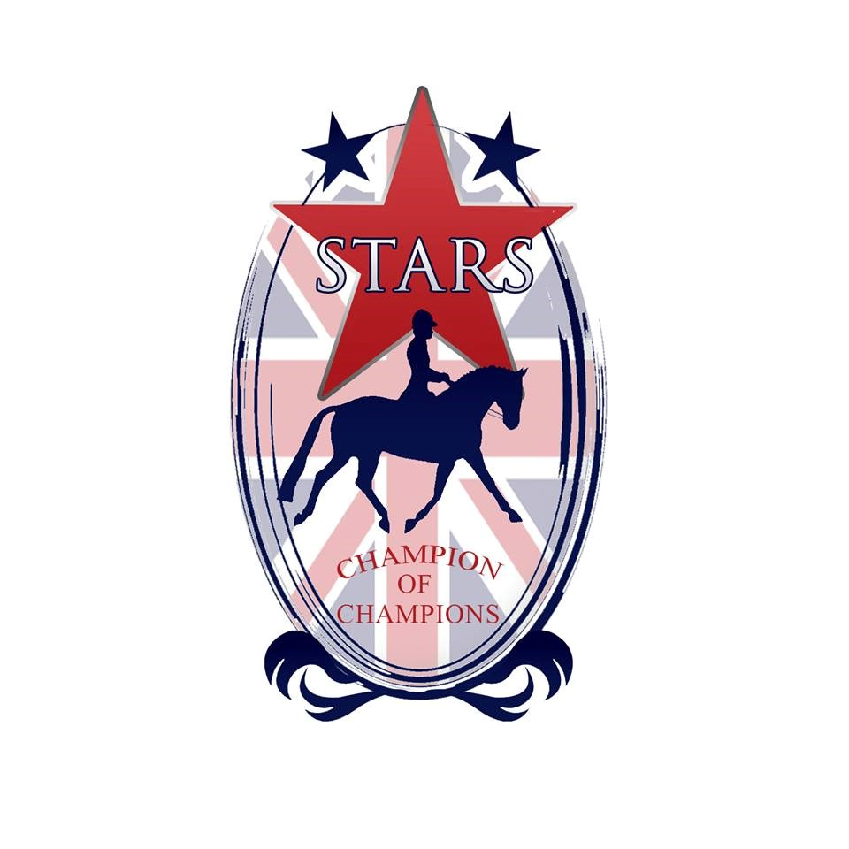

**\*DIRECTIONS: - Nord Vue Equestrian Centre is accessed from the M6 junc 41 or junc 42. Post code CA4 9TN. Take signs to Armathwaite from the southern end of High Hesket on the A6. Nord Vue is on the right hand side up a lane beside the utilites building.**

**Caledonian Showing Championships**

This show is a qualifier for the Caledonian Showing Championships, which offers competitors the opportunity to compete at a top level Championship Final in Scotland. With a draped main arena, amazing rosettes, special prizes, music, judges from the south and atmospheric Evening Performances, this is the show everyone wants to be part of. This year’s show will be held at

***Highfield @ Howe, near Ladybank, Fife on 17/18/19 October 2025***

Every horse & pony placed 1st in all In hand, Ridden Showing classes (not fun classes) & Working Hunter/Pony classes will qualify to compete in any appropriate class at the Finals. All Champions & Reserves will qualify for the Champion & Reserves Stakes Finals. Qualification will be from placings, no qualification cards will be awarded in the ring, and no qualification can go down the line.

***All qualified horses and ponies will be listed on the Caledonian Showing Championship Show’s website*** [***www.caledonianchampionships.co.uk***](http://www.caledonianchampionships.co.uk/) ***(under construction) or the Puddledub Shows Facebook page***

|  |
| --- |
| Top two placed exhibits in each In Hand and Ridden Class will qualify for The SPARKLE CHAMPIONSHIP SHOW on Sat/Sun 14th & 15th JUNE 2025.  Qualifying Cards will be available. |

**ROSETTE BUY BACK!!** Should you for whatever reason, return you rosette back to the office on SHOW DAY in AS NEW condition, you will receive £1 for it. This Eco-Friendly Scheme has been introduced for those

competitors who do not wish to keep their rosettes.

**STARS RULES**

- To qualify for STARS, combinations achieve placing Points in any STARS Class highlighted with a red star by the Class. Points can be gained from 2nd/3rd March Shows up and including the SPARKLE Shows on 14th and 15th June. The STARS Championships is at Aintree on 21st to 24th November 2024.

- The combination of Horse/Pony and Handler must stay the same, with no change of Handler.

- STARS is an amateur Championships, and professionals and Horses or Ponies stabled at a Producer’s yard are not eligible to compete at the STARS Championships, although **everyone, including all professionals are welcome at SPARKET Shows.**

- SPARKET Points will continue to be counted from every SPARKET Show as in previous years. Points will be published after every SPARKET Show in spreadsheet format.

- One combination from each STARS Class will qualify to go through to STARS Championships at Aintree. The qualifying combination will have the highest score from four SPARKET Shows. Competitors may attend more than four Shows, but the best four scores will count. If competitors attend less than four shows, two or three scores will count, **but you MUST attend TWO STARS Shows in ORDER to validate your STARS score.** Double points are awarded at the SPARKLE Championship Show.

**- For Equitation, Riding Club Horse/Pony Club Pony and all Working Hunter competitors, all points from all FOUR Shows will count. You do not need to attend all four Shows, but you MUST attend TWO STARS Shows in ORDER to validate your STARS score.**

- In order to participate in either Sparket or STARS Points, SPARKET Membership is needed for each competitor. Membership is £20 until 1st MArch, then an increased rate until until 1st June. Membership is voluntary, you only need Membership to gain points for STARS, or SPARKET sashes and/or rosettes, which from 2025 are free to SPARKET Members. SPARKET Membership is available on www.equoevents.co.uk

**- SPARKET Shows are, and always will be open to all, Members and Non Members.**

- Competitors are able to compete at STARS Championships representing two (or more if you have the time!) Clubs or Organisiations.

- Horses and Ponies competing at STARS Championships must be innoculated for Equine Flu with having had the last injection in the previous 6 months, but not within the previous 7 days.

- Stars Championships will be at Aintree 20th to 23rd November 2025 approx.

**Please see** [**www.starschampionships.co.uk**](http://www.starschampionships.co.uk/) **for all Classes & Rule details**

**RULES**

*All persons entering, competing or otherwise taking part in the above show shall be considered as having read and accepted the following regulations.

*NO CHILD AGED UNDER 3 YEARS ON SHOW DAY MAY COMPETE

*Numbers to be collected from the Secretary on the Show Day

*Riding Hats to standard BSI PAS015 1998, EN13841996, ASTM F1163, SNELLE2001, AS/NZS3838 1998, 2003, SAI GLOBAL must be worn at all times with the chinstrap fastened when mounted

*The Show organisers hold no responsibility for any accident occurring at this show.

*Horse Riding is a riskful sport, and you compete at your own risk.

*Horses must be four years old and over in all the ridden classes.

*Horses/Ponies DO NOT REQUIRE a JMB Height certificate.

*Any suitable bridles may be worn and handles on saddles in the Lead Rein are permitted.

*Spurs can only be worn when riding a horse exceeding 148cms. No Spur Rowels allowed.

*Spurs are not allowed in any Mountain & Moorland Classes.

*Earrings and or visible jewellry is allowed.

*Stallions/Colts MUST be handled by persons aged 14 years and over AT ALL TIMES and must not be left unattended at any time AND MUST WEAR STALLION DISCS.

*Any fall of horse/pony/rider in the class will result in immediate disqualification and they must leave the ring without re-mounting.

*Whips not to exceed 75cm (30”).

*The Judge’s decision is final.

* An exhibitor must not exhibit a horse/pony bred, sold, leased or produced by the Judge, his/her immediate family or his/her employer.

*An exhibitor may not show under a Judge for whom he/she has produced a horse in the same year.

*A rider may not ride in a class judged by someone for whom he/she has ridden in a competition during the current year.

*Competitors may be photographed for Sparket Equestrian Events Publicity in Newspapers, Magazines, Face Book and other media forms on Show Days. By taking part in any Sparket Equestrian Event competitors agree to being photographed for publicity purposes.

*Horse Riding can be a dangerous activity. Newton Rigg EC and/or Sparket Equestrian Events cannot be held responsible for libelous actions at his event by competitors or otherwise.

Ridden Warm Up is available on completion of In Hand Classes.

*PLEASE NOTE NO LUNGING AT ANY TIME in car park or arena.

*Anyone found to be misusing or abusing any person or animal (including horses) will be EVICTED from the premises IMMEDIATELY with no appeal.

*The use of side or running or draw reins is forbidden at any time.

* Any objections must be forwarded to the Secretary with £40 cash and a signed letter of complaint. Should the complaint be upheld the £40 cash will be returned to the objector.

This Show is affiliated to Equifest, taking place at the ArenaUK, Grantham on the **6th – 9th August 2024.** The **two** highest exhibits not already qualified in each affiliated class will qualify.

**9:30am, – Judge Mrs EJ Murray, Peebles. Whole large Arena**

1. **STARTER Ridden Small Breeds M&M Pony, (Reg & Unreg Pony) Snaffles Only.** Go Round in Walk & Trot. Rider any age, optional canter in individual show, SNAFFLE BITS Only.

2. **STARTER Ridden Large Breeds M&M Pony, (Reg & Unreg Pony) Snaffles Only.** Go Round in Walk & Trot. Rider any age, optional canter in individual show, SNAFFLE BITS Only.

3. **Novice Ridden Small Breeds M&M, snaffles only.** Registered ponies only.

4. **Novice Ridden Large Breeds M&M, snaffles only.** Registered ponies only.

5. **Amateur Ridden M&M.** Registered M&M pony ridden & owned by any age of rider who doesnt receive income from Training, schooling or breaking ponies & doesnt receive income from giving riding lessons and/or training. Ponies can be Novice or Open and the rider doesnt have to be the same person. Rider can be unrelated to Pony’s owner. NB. Both Rider and Owner need to be Amateurs as defined above. Any suitable bit. Registered ponies only.

6. **Equifest JUNIOR RIDDEN MOUNTAIN & MOORLAND**

Mares and geldings, 4 years old & over, registered in the respective pure bred Stud Books of Connemara, Dales, Dartmoor, Exmoor, Fell, Highland New Forest, Shetland and Welsh Section A, B, C & D. Riders of Small Breeds not to have attained their 14th birthday before 1st January in the current year. Riders of Large Breeds not to have attained their 18th birthday before 1st January in the current year.

**Equifest OPEN RIDDEN MOUNTAIN & MOORLAND**

Open to Mountain & Moorland ponies registered with their respective Pure Bred Societies, mare or gelding, 4 years old and over. Rider any age. To be split as follows -

7) Dartmoor, Exmoor, Shetland, Welsh A, B, - **This is a STARS points Class.**

8) Connemara, Dales, Fell, Highland, New Forest, Welsh C and D. - **This is a STARS points Class.**

**CHAMPIONSHIP, Classes 1 to 8, 1st & 2nd PRIZE WINNERS eligible**

**11:30 am approx, Judge - Mrs EJ Murray, Peebles. Split Large Arena.**

9. **Best Turned Out - This is a STARS points Class.**

Open to any age rider, horse or pony. LR ponies eligible for this Class. To be judged as follows -

30% tack, 30% Pony/Horse, 30% rider, 10% overall impression. This is a STARS points Class.

10. **STARTER Ridden Plaited/Hogged Novice Pony, Any type, Go round in Walk and Trot only,** Rider any age, optional canter in individual show, SNAFFLE BITS Only.

11. **RIDDEN SHOW PONIES (Mixed Height) - This is a STARS points Class. No rider age limit.**

Open Show Pony, mare or gelding, 4 yrs old & over, not exceeding 148cm.

12.  **RIDDEN SHOW HUNTER PONIES (Mixed Height) - This is a STARS points Class. No rider age limit.** Show Hunter Pony, mare or gelding, 4 yrs old & over, not exceeding 153cms.

13. **Equifest OPEN RIDDEN PART BREDS**

Stallion, mare or gelding, 4 years old and over. Exhibits in this section must be registered in the Part Bred section of their respective Breed Society. Horses and ponies will not be ridden at the final. Riders any age.

14. **Equifest Young Riders – NEW CLASS-**

Mare or gelding, exceeding 146cms but not exc 158cms. Riders not to have attained their 25th birthday before 1st January in the current year. Open to any type of horse – Hack, Hogged Cob, Traditional Cob, Riding Horse, Hunter or RoR. Horses will not be ridden by the Judge.

**CHAMPIONSHIP, Classes 9 to 14, 1st & 2nd PRIZE WINNERS eligible**

**11:30am approx, Judge – Mrs R Eastwood, Stranraer. Small Arena**

15. **TINY TOTS Lead Rein Pony, plaited/M&M/coloured, under 122 cm,**

Riders not to have attained their 6th birthday before 1st Jan in current year.

16. **Home Produced Lead Rein Pony of any type not exc 128cm.**

Pony and rider must meet the age & height criteria for one of the above Lead Rein Classes.

Pony must not have been stabled in the yard of a professional Professional Producer or Trainer Yard since 1st Feb of the current year. Rider must not have ridden a pony for a Producer/Trainer since 1st Feb in current year. Pony must not be owned by anyone who has taken payment for Training or Producing ponies since 1st Jan of current year.

17. **LEAD REIN SHOW PONY/SHOW HUNTER PONY as below -** To be led by an attendant and shown in a snaffle bridle. Lead rein to be attached to the noseband only.

**PLEASE NOTE ONE SET OF ROSETTES FOR THIS CLASS.** This is a STARS points Class.

Leading Rein Show/Show Hunter Pony, mare or gelding, 4 years old & over over not exceeding 128cms. Riders not to have attained their 10th birthday before 1st January in the current year.

18. **EQUIFEST OPEN MOUNTAIN & MOORLAND LEAD REIN** Open to Mountain & Moorland ponies, registered with their respective Pure Bred Societies of Dartmoor, Exmoor, New Forest, Shetland and Welsh A or B. Mare or gelding, 4 years old and over, not exceeding 128cms. Riders not to have attained their 9th birthday before 1st January in the current year. To be led by an attendant and shown in a Snaffle Bridle, the lead rein to be attached to the noseband only. This is a STARS points Class.

**CHAMPIONSHIP, 1st & 2nd  PRIZE WINNERS from Classes 15 to 18 eligible**

**1pm approx, Judge – Mrs R Eastwood, Stranraer. Small Arena**

19. **TINY TOTS First Pony, M&M/plaited/traditional/coloured, under 128cms,**

Riders not to have attained their 9th birthday before 1st Jan in current year.

20. **Home Produced Plaited or M&M First Ridden Pony.** Pony and rider must meet the age & height criteria for one of the above First Ridden Classes. Pony must not have been stabled in the yard of a professional Professional Producer or Trainer Yard since 1st Feb of the current year. Rider must not have ridden a pony for a Producer/Trainer since 1st Feb in current year. Pony must not be owned by anyone who has taken payment for Training or Producing ponies since 1st Jan of current year.

21. **COMBINED FIRST RIDDEN SHOW PONY and FIRST RIDDEN SHOW HUNTER PONY. PLEASE NOTE ONE SET OF ROSETTES FOR THIS CLASS.**

First Ridden Show Pony or Show Hunter Pony, mare or gelding, 4 years old & over over not exceeding 128cms. Riders not to have attained their 12th birthday before 1st January in the current year. This is a STARS points Class.

22. **EQUIFEST MOUNTAIN & MOORLAND FIRST RIDDEN** Open to Mountain & Moorland ponies, registered with their respective Pure Bred Societies of Dartmoor, Exmoor, New Forest, Shetland and Welsh A or B. Mare or gelding, 4 years old and over, not exceeding 128cms. Riders not to have attained their 12th birthday before 1st January in the current year. To be shown in any suitable bridle. This is a STARS points Class.

**MINI CHAMPIONSHIP, CLASSES 19 to 22, 1st & 2nd PRIZE WINNERS eligible.**

**12.30pm approx, – Judge -Mrs EJ Murray, Peebles. Split Large Arena.**

23. **STARTER Ridden Novice Horse/Pony, Any Type, Go round in Walk and Trot only,** Rider any age, optional canter in individual show, SNAFFLE BITS Only.

24. **EQUIFEST OPEN RIDDEN VETERAN HORSE/PONY aged 15 years to 19 years.** Open to horses and ponies of all types including Lead Rein.

This Class is a STARS Points Class for the STARS Champion of Champions.

25. **EQUIFEST RIDDEN VETERAN HORSE/PONY aged 20 years and over.** Open to horses and ponies of all types including Lead Rein.

This Class is a STARS Points Class for the STARS Champion of Champions.

**CLASS 26, RIDDEN HUNTER ONWARDS IN WHOLE LARGE ARENA.**

**Lunchbreak before Class 26.**

26. **EQUIFEST OPEN RIDDEN HUNTER & EQUIFEST OPEN SMALL HUNTER**

Open Ridden Hunter, mare or gelding, 4 years old and over, exceeding 148cm. Riders any age. Open Small Hunter, mare or gelding, 4 years and over, exceeding 148cm but not exceeding158cm. Riders any age.

This Class is a STARS Points Class for the STARS Champion of Champions.

**27. EQUIFEST OPEN RIDDEN HACKS**

Open Show Hacks, mare or gelding, 4 years old & over over, exceeding 148cm, but not exceeding 160cms. Riders any age.

**28. EQUIFEST OPEN RIDING HORSES**

Open Riding Horse, mare or gelding, 4 years old and over, any height. Riders any age.

**29. Ridden Plaited Show Horse exceeding 148cm.** Riders any age. This is a STARS Points class.

**30. OPEN RE-TRAINED RACE HORSE**

Thoroughbred mare or gelding, 4 yrs old and over, any height. This is a STARS points Class. NB. In order to compete at STARS at Aintree, Horses must be RoR registered.

**31. OPEN RIDDEN COBS**

Open Ridden Cob, mare or gelding, 4 years old & over. Open to Hogged/Traditional/Native Cobs of any type. Riders any age. This is a STARS points Class.

**CHAMPIONSHIP, Classes 23 to 31, 1st & 2nd PRIZE WINNERS eligible**

**3:00pm approx, - Judge – Mrs R Eastwood, Stranraer. Large Arena**

**32. STARTER Ridden Novice Pony/Horse, Any type, Go round in Walk and Trot only,** Rider any age, optional canter in individual show, SNAFFLE BITS Only.

**33. Junior Ridden Coloured Pony of Any Height/Type.**  Riders not to have attained their 18th birthday before 1st January in the current year. No Lead Rein ponies.

**34. Amateur Ridden Coloured Horse/Pony. NEW CLASS** Ridden & owned by any age of rider who doesnt receive income from Training, schooling or breaking ponies & doesnt receive income from giving riding lessons and/or training. Ponies can be Novice or Open and the rider doesnt have to be the same person. Rider can be unrelated to Pony’s owner. NB. Both Rider and Owner need to be Amateurs as defined above. Any suitable bit. No Lead Rein ponies.

**35. Ridden Plaited Coloured Horse or Pony, Any Height. This is a STARS points Class.**

**36. Ridden Hogged Coloured Cob,** Any Height.

**37. Ridden Native Coloured Cob**

**38. Ridden Traditional Coloured Cob,** Any Height.

**39. Ridden Traditional Solid Colour Cob,** Any Height, Full feather and mane & tail.

**40. Ridden Native/Hogged/Traditional Coloured Horse/Pony. This is a STARS points class.**

**41. EQUIFEST RIDDEN PIEBALD/SKEWBALD.** Open ridden Piebald/Skewbaldstallion, mare or gelding, 4 yrs old & over. Riders any age. The first three places will also qualify for the BSPA Championship subject to their show rules & conditions.

**CHAMPIONSHIP, Classes 32 to 41, 1st  & 2nd PRIZE WINNERS eligible**

*This Event is being organised by Ellen Jones as an SPARKET EQUESTRIAN EVENT.

*Enquiries: -07787570736 [www.sparketequestrianevents.co.uk](http://www.sparketequestrianevents.co.uk/) for other event details

*ENTRIES £13/£15 per Class. Entries close Wednesday 23rd April 2025

*ENTRIES ON THE DAY £20. CASH and CARD accepted.

SPARKET 2025 DATES AS FOLLOWS -

Sat March 8th – Nord Vue Ridden Show

Sun March 9th – Nord Vue In Hand Show

Sun Mar 23rd – Nord Vue WH/Performance Show

Sat April 5th – Nord Vue In Hand Show

Sun April 6th – Nord Vue Ridden Show

Sat Ap 19th – Nord Vue WH/Performance Show

Sat April 26th – Nord Vue Ridden Show

Sun April 27th – Nord Vue In Hand Show

Sun May 4th – Nord Vue WH/Performance Show

BH Mon May 5th – Nord Vue In Hand Show

Sun May 11th – Nord Vue Ridden Show

Sat May 31st - Nord Vue Last Minute SPARKLE

Ridden Qualification Show

Sun June 1st - Nord Vue Last Minute SPARKLE

In Hand Qualification Show

Sun Jun 8th – Nord Vue WH/Performance Show

Sat June 14th IN HAND SPARKLE

Sun June 15th RIDDEN SPARKLE

Sun 13th July – Ridden Show inc NPS Quals

Sun 19th Oct - Venue TBC In Hand/Ridden Show

Sun 2nd Nov – Venue TBC Foal/In Hand/Ridden Show

All Shows highlighted are STARS Points Shows

schedules on [www.equoevents.co.uk](http://www.equoevents.co.uk/) under SPARKET EQUESTRIAN EVENTS

schedules also on www.sparketequestrianevents.co.uk